1. Create a “Friend”. ASP.NET MVC Project
2. Create a “FriendTable ” with following properties : FriendID,FriendName,Place
3. Create a List of Friends and display in Table The Edit is a HyperLink based on FriendID   
   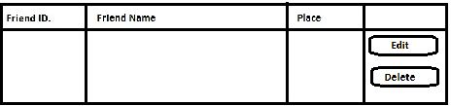
4. Handle the Errors “ Friend Name Empty Not Allowed.” And place Cannot be blank error using Data Annotations
5. Create a Insert new friend   
     
   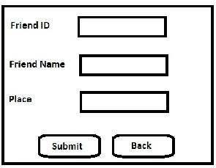
6. Update record   
   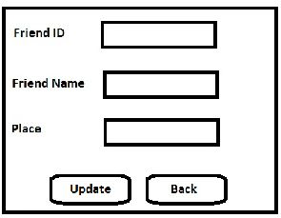

If a person is no more a friend delete him from the Database.

1. Use Entity Framework for Database concepts
2. ASP.NET MVC to design the web pages